

**Kofax SmartHub Connector**

**D365 Customer Engagement (CE) Connector for KTA**

August 2021  
Version 1.0

Table of Contents

Overview 3

What is the Kofax D365 CE Connector? 3

Why Kofax Smart Hub? 3

D365 CE Connector Architecture 3

Configuration and Usage 4

How do I download the D365 CE Connector project from SmartHub? 4

Prerequisites 4

Required Set Up 4

Document Ingestion into KTA 9

How do I know if the record is created? 9

Limitations 9

Frequently Asked Questions 10

Overview

What is the Kofax D365 CE Connector?

The KTA D365 CE Connector allows users to send data – extracted by KTA – to your desired D365 CE deployment through the D365 CE API. Currently, the primary use case for the connector is for sending case forms and their extracted data through to D365 CE. We are looking to expand this capability in the future.

The KTA connector built with D365 CE provides processing of documents and images in various supported formats via the D365 CE REST APIs. A series of API calls are used to pull data from your D365 CE deployment in addition to the extracted data from your documents, and both data sources are combined which is used to create new records in D365 CE.

Why Kofax Smart Hub?

Kofax SmartHub is a digital showcase of assets connecting customers with pre-built, integrated components and solutions to extend their digital workforce. The D365 CE Connector solution will be easily available on SmartHub, built on top of Kofax’s Intelligent Automation platform. It accelerates customer automation journeys and reduces the need for custom development work. SmartHub also allows partners to expose their value-added solution to new prospects and customers.

D365 CE Connector Architecture

The D365 CE Connector uses the D365 CE REST API to pull data from your D365 CE instance as well as to push data to it. Here is the architecture diagram:

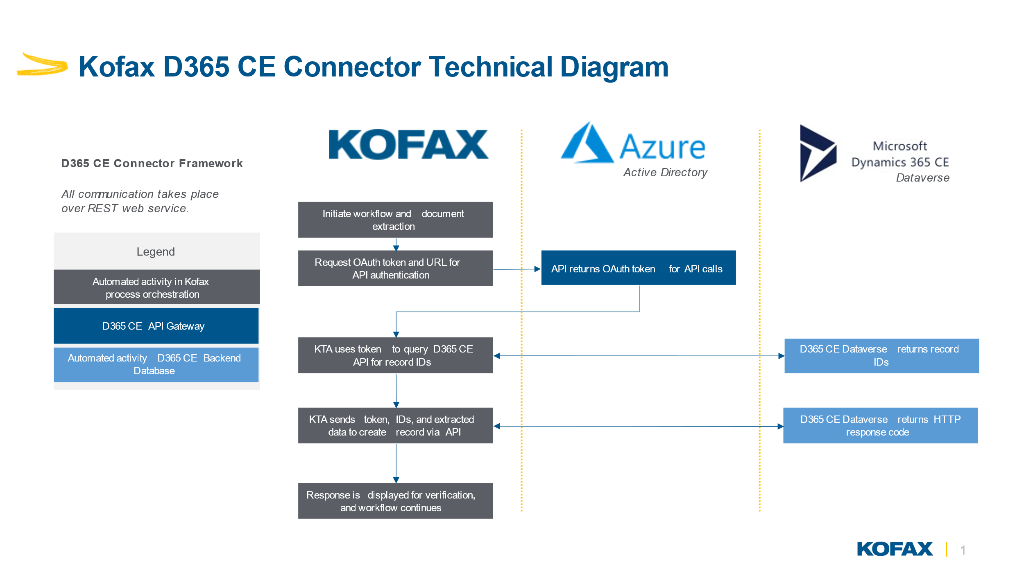

Configuration and Usage

How do I download the D365 CE Connector project from SmartHub?

The solution is available at <https://smarthub.kofax.com/> and downloadable from Github. Instructions to set up are down below as well as in the README.

Prerequisites

You will need the following in order to utilize this connector:

* KTA Version 7.8 or higher
* Azure Active Directory
  + Admin access or someone with admin access is required
* D365 Customer Engagement - Sales Enterprise or Sales Pro
  + Admin access or someone with admin access is required

Required Set Up

There are several steps needed to get the connector working, both in D365 CE and in KTA. The 4 main components are the D365 CE data objects (accounts, contacts, etc.), the Azure Active Directory/D365 app (for authentication), the KTA server variables (used to store credentials for authentication), and the KTA scanning workflow (extracts information out of documents and sends to D365 CE).

You may use the one provided as a template, but are free to create your own as long as the above data is supplied to D365 CE

Case Form Document Scanning

You will need to set up a document scanning process to extract the data you need. Note that the blue section is all optional, but recommended to send as much information as possible:

|  |  |
| --- | --- |
| **Key** | **Value** |
| Account Name | Name of the account in D365 CE (exact match) |
| Subject | The subject of the case (“repair request for computer”) |
| Description | The detailed description of the case (“repair request for computer fan which is really loud”) |
| Additionally, for authentication you will need to provide: | |
| Directory Tenant Id | The ID of your Azure tenant |
| App Client ID | The Application key’s ID of the app you create in Azure AD |
| Client Secret Value | The Secret key’s value (NOT the ID) of the app you create in Azure AD |
| Instance URL | The base URL used to access your D365 instance |

D365 CE Data Objects

1. Obtain access to a D365 CE instance and log in
   1. Either a test or production instance will work
2. Create or modify an account to exactly match the names supplied by the case form

D365 CE Azure AD App

1. Ensure you or someone you work with has administrator access to your D365 CE instance
2. Log in to the [Azure Portal](https://portal.azure.com/#home) and navigate to Azure Active Directory
3. Click “App registrations” on the left menu
4. Create or edit a registration
   1. To create, give it a meaningful name
   2. Select the second option “Accounts in any organizational directory (Any Azure AD directory – Multitenant)”
   3. Click register
   4. Click Manifest on the left menu
   5. Change line 6 “allowPublicClient” from null to true and click save at the top
   6. Click API permissions on the left menu
   7. Click add a permission
   8. Select Dynamics CRM
   9. Select “user_impoersonation”
   10. Click Add permissions
   11. [ADMIN] Click “grant admin consent for [app name]” then click yes
5. On this screen, make note of the “Application (client) ID” and the “Directory (tenant) ID”
6. To the right of “Client credentials”, new client secret (click the link if it already exists)
7. Click “New client secret” and enter the information required
8. IMPORTANT: make sure to copy the VALUE (not the secret ID) of the key, this is last time you will see it. Otherwise you will have to create a new one
9. Navigate to the [Power Platform admin center](https://admin.powerplatform.microsoft.com/) and either create or edit a D365 CE environment
10. Click Setting at the top, then expand the “Users + permissions” section and click “Application users”
11. Set up app user (or “new app user” if one already exists)
12. On the pop up modal, select your app from Azure AD, business unit, and security roles (system admin if unsure), then click Create

KTA Server Variables

You will need to set up the KTA Server variables which are comprised of your login information needed to use the D365 CE REST API:

|  |  |
| --- | --- |
| **Key** | **Value** |
| Application (client) ID | The app client ID noted from Azure AD |
| Client Secret Value | The client secret VALUE created in Azure AD |
| Directory (tenant) ID | The ID associated with the tenant noted from Azure AD |
| Instance URL | The base URL of the D365 instance (like <https://org12345.crm.dynamics.com>) |

1. Log into KTA
2. Click Import on the left side menu
3. Import the downloaded D365 CE Connector from SmartHub
4. In the left menu, click System Data then Server Variables (can be changed at any time)
5. Click New (or edit the existing) and enter in the required info
   1. Name can be anything, something like “appClientId”
   2. Category should be “D365CE Connector” unless you renamed it
   3. ID is auto populated
   4. Type is “String”
   5. Paste your Application (client) ID for the value
6. Repeat this for your Client Secret Value, Directory (tenant) ID, and Instance URL
   1. Names can be anything, recommended format is “clientSecretValue”, “directoryTenantId”, and “instanceUrl”,
   2. Optionally, you can select the “Secure” box to obfuscate any sensitive data
7. Click into the “Case Form to D365CE” process
8. Click the activity labeled “D365CE Connector Service”
9. Fill out the first 4 parameters with the corresponding server variables you just created, in the “server variables” tab
10. Click OK, then at the top right click Save, Release, then Close and Unlock

Document Ingestion into KTA

Users have a lot of flexibility with how they ingest documents into KTA for extraction. There are 2 main methods to go about this.

It is recommended that documents are ingested by KTA through a scan form generated by KTA. This is used to kick off the document scan process that you set up, which will then pass the data into the D365 CE Connector.

You may also set up a document listener to watch a specific folder on your local machine, so if you move a document into that folder KTA will automatically process it. This works for individual users but is not as scalable for teams.

How do I know if the record is created?

When the process is complete, you will be presented with a form containing the response code that KTA received after it has sent to your D365 CE deployment.

You can then verify the record that was created within D365 CE, and make sure that everything is as expected. If they do not align, it is highly recommended to go over the extracted data as well as the information that is supplied to the connector.

Limitations

Cases

The D365 CE Connector can currently only create one (1) case from each scanned document.

The names of the account that is provided to the D365 CE Connector must exactly match the name in D365 CE. Only the account value is mandatory, so if you leave the others blank it will push that information out. The connector queries the D365 CE API for objects by their name. If the names on the document do not exactly match the names in D365 CE, the query will not find the record and will not be able to perform the desired action.

Frequently Asked Questions

Below is the list of possible questions gathered to answer the basic questions about storage and detection

How do you secure the transfer of the data? and what happens after the document is uploaded to the server?

Data transfer is handled via secure TLS connection. Each user is authenticated using an API key in the https header. Upon submitting a file to the server, a unique ephemeral environment is deployed to process the file. As soon as the analysis is complete, the environment is destroyed, and the result of the analysis is returned to the caller.

How many documents can the system process simultaneously?

The solution is designed to process documents in parallel and independently from one another. The maximum allowed time in the test to process the 1,000 documents simultaneously is 60 second. The case functionality will only create one (1) case per document.